**Lovely Professional University**

**Phagwara , Punjab**



**Final Report:**

**Course Code- CSE326**

**Submitted to- Ishan Kumar**

**Title- Coding Website**

**Section-K19KP**

**GROUP STUDENTS:**

**NAME: REG NO. ROLL NO.**

**Vishal Sharma 11910520 50**

**Palnati Pavan 11911049 51**

**kumar**

Introduction:

This coding-website will contain all the necessary information for the user.

* Practice problems for the user.
* List of Top programming language.
* List of Top problems.
* Access to compilers of different language.

The website will also have various tabs - .

* Home
* Practice
* Code Library
* Contact us
* Login

The website is perfectly designed and according to outlines provided by the teacher. It’s easy to access

And have a neatly created set of pages.

# For implementing this website we used-

* Html
* Implementing CSS
* Fonts, colors, designs, etc
* Different classes and ID’s
* Backgrounds & Borders
* Box Model/Margin & Padding
* Grids
* Floating & Alignment
* Display property
* Link & Button Styling
* Javascript
* jQuery
* Bootstrap

## Tasks done by group members:

*Vishal Sharma*

*Reg no. : 11910520*

*Designed the HOME page, PRACTICE page, CODING LIBRARY page, CONTACT US page, LOGIN page and wrote the synopsis and final report.*

*Palnati Pavan*

*kumar*

### Reg no. :11911049

*Help in managing and preparing the writing section (synopsis and final report), helped in coding for the CSS of all the pages.*

#### THE HOME PAGE

##### First we created the homepage :

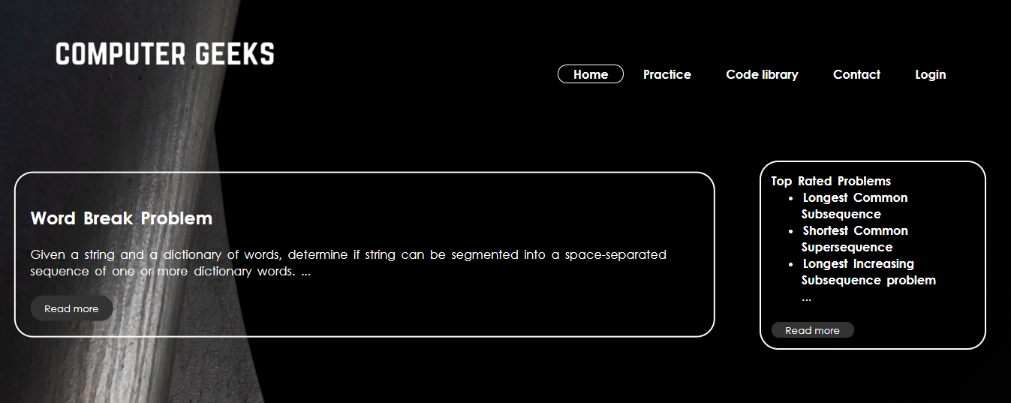

First, we included the <!doctype html> which is used to inform a website visitor’s browser that the document being rendered is an HTML document.

Then the <head> tag which contains metadata (document title, character set, styles, links, scripts), specific information about the web page that is not displayed to the user. Metadata provides browsers and search engines with technical information about the web page.

The <head> includes the following elements:

* The <title> tag defines the title of a web page (required).
* The <h1> tag specifies the title of page content, whereas the <title> tag is metadata representing the title of the entire HTML content and not its content.
* The <style> tag contains CSS code that defines how HTML elements should be rendered in a browser.
* The <link> tag defines the relationship between the current HTML document and the resource to which it refers, or contains a link to an external style sheet. It can have two attributes: rel=”stylesheet” and “href”.
* The <meta>tag provides additional information (metadata) about HTML document. The <head> of a page can include different kinds of <meta> elements that may contain “name” and “content” attributes

Then we added:

<title>project</title>

<meta charset=”utf-8”>

<meta name=”viewport” content=”width=device-width, initial scale=1.0” >

<link rel=”stylesheet” href=”stylesheets.css”>

* Here we included the title tag, meta and css file using the <title>, <meta> and <link> tags.
* Then we added the body tag

<body>

* Created header and a class “ headin” ( note: this is responsible for the navigation menu )

<header class=”headin” >

* Created a class “main”.

<div class=”main”>

* Created a class “logo” for adding and fixing the logo.

<div class=”logo” >

* Created a list using <ol><li> </li><ol> tags for the navigation menu tab.
* Here <a> tag is also used to link the option to the pages to their respective html files.

<a href=”../homepage/index.html”><img src=”logo.png”></a>

<ul class=”hpage”>

<li><a class=”active” href=”../homepage/index.html” >Home</a></li>

<li><a href=”../practice/PRACTICE.html”>Practice</a></li>

<li><a href=”../coding_library/index.html”>Code library</a></li>

<li><a href=”../contact/contactform.html”>Contact</a></li>

<li><a href=”../Login/login.html”>Login</a></li></ul>

* After we created a class “wrapper” in which we created classes “top-container” and “bottom-container”.
* “showcase1” , “showcase2”, “showcase3”, “showcase4”, “top-rated-a” and “top-rated-b”

<div class=”wrapper”>

<section class =”top-container”>

* We also added the read more button using jQuery

<button onclick=”readMore(‘buda’)” class=”myBtn”>Read more</button></header>

* As we created the read more button we also used jQuery to create it, we added the function readMore(parameter).

<script>

function readMore(city) {

let dots = document.querySelector(‘.card[data-city=”${city}”] .dots‘);

let moreText = document.querySelector(‘.card[data-city=”${city}”] .more‘);

let btnText = document.querySelector(‘.card[data-city=”${city}”] .myBtn‘);

if (dots.style.display === “none”) {

dots.style.display = “inline”;

btnText.textContent = “Read more”;

moreText.style.display = “none”;

} else {

dots.style.display = “none”;

btnText.textContent = “Read less”;

moreText.style.display = “inline”;

}

}</script>

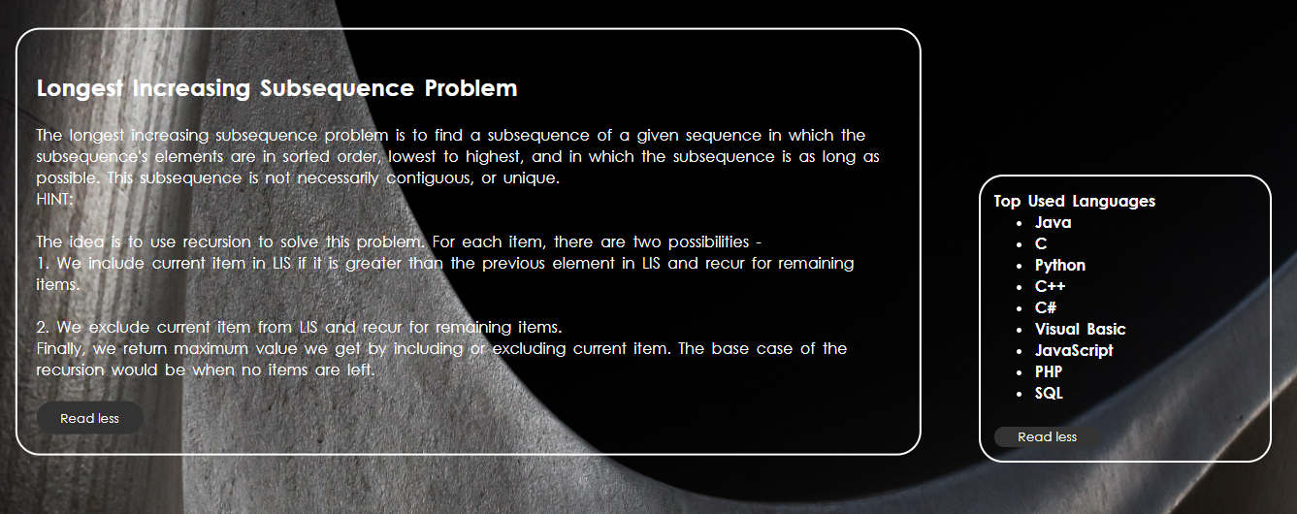

-We also added buttons at every page

-using the code

<a href="../contact/contactform.html" class="btn previous">&laquo; Previous</a>

<br>

<a href="#" class="btn next">Next &raquo;</a>

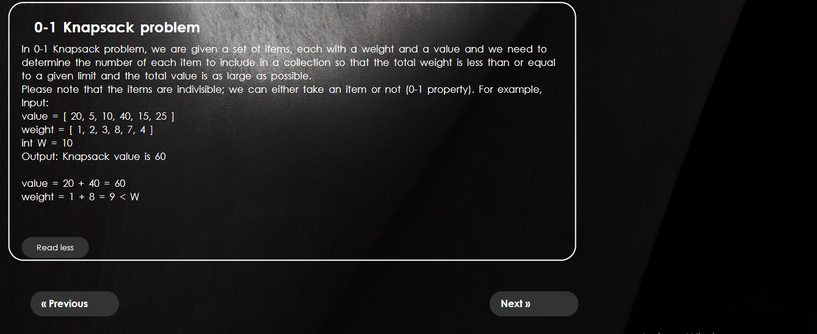

ABOUT CSS IN HOMEPAGE

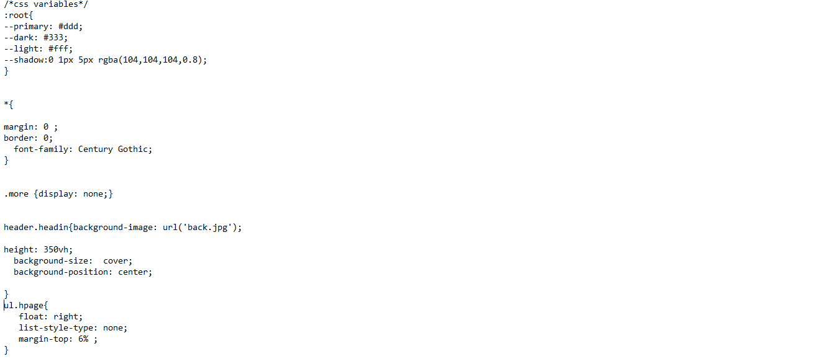

* In css we first created some variables.
* Then we used universal selector.
* And designed the different classes and <div>s giving them style

using -

*{

border: 0;

font-family: Century Gothic;

}

.more {display: none;}

header.headin{background-image: url(‘back.jpg’);

height: 350vh;

background-size: cover;

background-position: center;

}

ul.hpage{

float: right;

list-style-type: none;

margin-top: 6% ;

}

• And using much more styling for every grid, header, id and class created in html.

* We also added media queries so that the website can work at any resolution:

/* Media Queries */

@media screen and (max-width:1135px)

**Practice page**

* After the homepage we created the practice page.



* First we created the navigation menu and added the logo just like the home page.
* The added a table containing some programming questions.

Using the <table> tag.

In which each table row is defined with the <tr> tag. A table header is defined with the <th> tag. By default, table headings are bold and centered. A table data/cell is defined with the <td> tag.

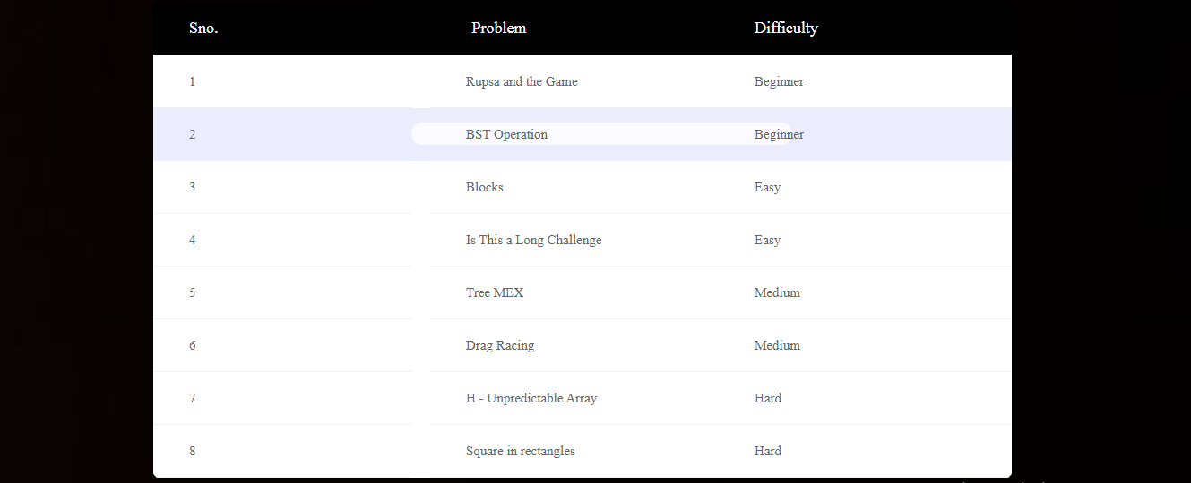

* We also added some topics questions and links so, that user can access them.

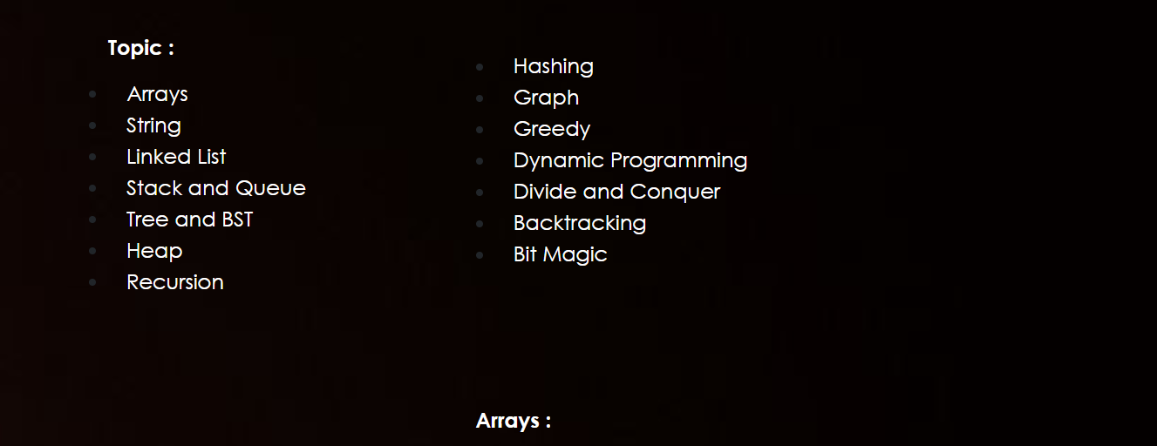

CSS FOR THE PRACTICE PAGE

* For the css part we use different properties for styling and giving the elements their font-size, border, color, background-image etc.
* Also added media queries so the website can work in any device.

Code library page



* Coding library page contains a lot of links to compiler and different programming languages
* First we added he logo and navigation menu
* Then we added the grids, which represent different languages compilers and contains information about them.
* We divided them in different sections using<section >tags.

<section class=”4u”>

<p>As C gave low-level access………………………………</p>

</section>

<section class=”4u”>

<p>Bjarne Stroustrup has……………</p></section>

Contact page

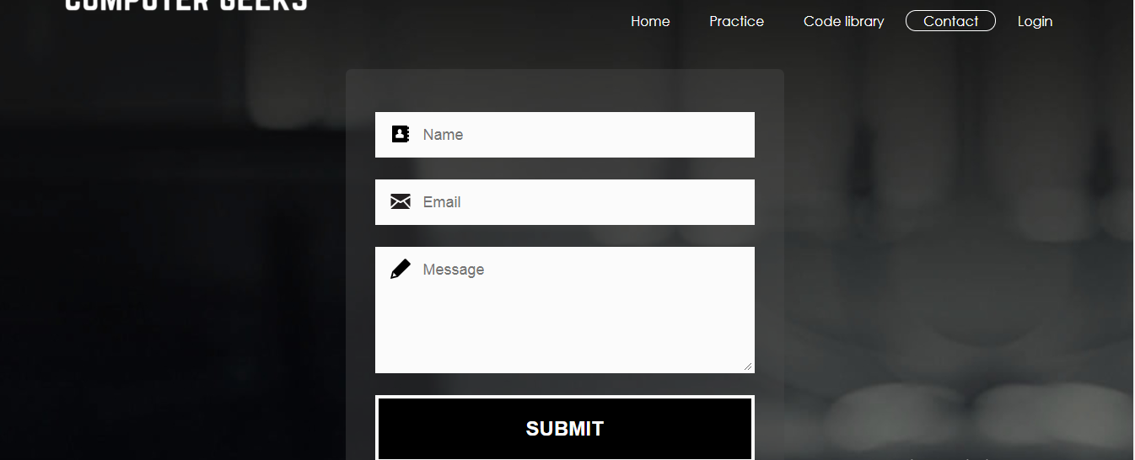

* First created the navigation bar and then
* Created the form which contains name ,email, message and a submit button.

Using the code:

<input name=”name” type=”text” class=”feedback-input” required placeholder=”Name” id=”name” />

</p>

<p class=”email”>

<input name=”email” type=”email” required class=”feedback-input” id=”email” placeholder=”Email” />

</p>

<p class=”text”>

<textarea name=”message” class=”feedback-input” id=”comment” placeholder=”Message”></textarea>

</p>

<div class=”submit”>

<button type=”submit” class=”button-blue”>SUBMIT</button>

* Here we also used an input tag

<input> tag specifies an input field where the user can enter data.

<input> elements are used within a <form> element to declare input controls that allow users to input data.

An input field can vary in many ways, depending on the type attribute.

**Login page**

* And at the end we created the login page which contains different options

Using the code:

<input type=”text” name=”username” placeholder=”Username” />

<input type=”text” name=”email” placeholder=”E-mail” />

<input type=”password” name=”password” placeholder=”Password” />

<input type=”password” name=”password2” placeholder=”Retype password” />

<input type=”submit” name=”signup_submit” value=”Sign me up” />

</div>

<span class=”loginwith”>Sign in with<br />social network</span>

<button class=”social-signin facebook”>Log in with facebook</button>

<button class=”social-signin twitter”>Log in with Twitter</button>

<button class=”social-signin google”>Log in with Google+</button>

* This included using <button> tag and <input > tags.